**KGiSL INSTITUTE OF TECHNOLOGY: COIMBATORE**

(Approved by AICTE & Affiliated to Anna University, Chennai)

**GE8161**

**Problem Solving and**

**Python Programming Laboratory**

LAB PREPARATION GUIDE

Department of Computer Science and Engineering

**KGiSL INSTITUTE OF TECHNOLOGY**

Saravanampatti, Coimbatore-35

**GE8161 PROBLEM SOLVING AND PYTHON PROGRAMMING LABORATORY**

**LIST OF PROGRAMS**

**Part I**

1. Compute the GCD of two numbers.
2. Find the square root of a number (Newton‘s method)
3. Exponentiation (power of a number)
4. Find the maximum of a list of numbers

5a. Linear search   
8. Generate prime numbers

10. Command line arguments (word count)

**Part II**

5b. Binary search

6a. Selection sort  
 6b. Insertion sort

7. Merge sort

9. Multiply matrices

11. Find the most frequent words in a text read from a file

**Pygame**

12. Simulate elliptical orbits in Pygame

13. Simulate bouncing ball using Pygame

|  |  |
| --- | --- |
| **Ex No: 1** | COMPUTE THE GCD OF TWO NUMBERS |

**AIM**

Write a Python program to compute the greatest common divisor (***gcd***) of two positive integers.

**ALGORITHM**

Function: **GCD**

**Parameters**: number1, number2

Step 1: while number2 is not 0,   
 Step 1a: number1, number2 = number2, number1 % number2

Step 2: return number1 as GCD

**FLOWCHART**

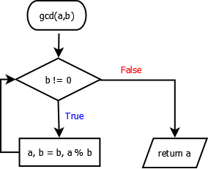

**PROGRAM**

def gcd(a, b):

while b != 0:

(a, b) = (b, a % b)

return a

**TESTING**

a = 12

b = 24

print ('The gcd is ', gcd(a, b))

**OUTPUT**

The gcd is 12

**RESULT**

Thus the python program to compute the greatest common divisor (***gcd***) of two positive integers has been written, executed and verified successfully.

|  |  |
| --- | --- |
| **Ex No: 2** | THE SQUARE ROOT (Newton’s Method) |

**AIM**

Write a Python program to Implement a python program that determines the square root of a number using the Newton's method.

**ALGORITHM**

Step 1: Initialize  
 epsilon = 0.01

k = number

guess = k / 2.0

Step 2: while (abs(guess * guess- k) >= epsilon) :

guess = guess - (guess **2 - k) / (2 * guess)

Step 3: return guess

**FLOWCHART**

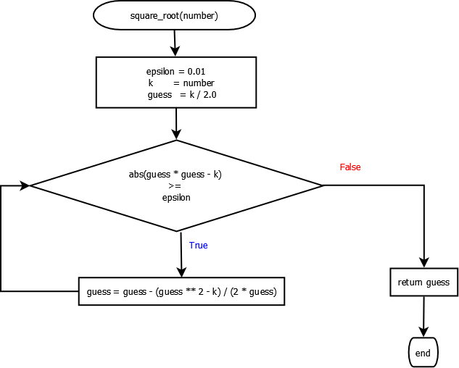

**PROGRAM**

def square_root(number):

epsilon = 0.01

k = number

guess = k / 2.0

while abs(guess * guess - k) >= epsilon:

guess = guess - (guess ** 2 - k) / (2 * guess)

return guess

**TESTING**

a = int(input())

print (square_root(a))

**OUTPUT**

2

1.4166666666666667

**RESULT**

Thus the python program to compute the square root of a number using Newton’s method has been written, executed and verified successfully.

|  |  |
| --- | --- |
| **Ex No: 3** | EXPONENTIATION (POWER OF A NUMBER) |

**AIM**

Write a Python program to compute the power of a given number.

**ALGORITHM**

Function: **EXPONENT**

**Parameters**: base, exp

Step 1: Initialize  
 answer = 1.0

Step 2: if the input parameters are not valid,   
 return “invalid input”  
Step 3: if ‘exp’ is positive number (>=0),  
 multiply base ‘exp’ times and store it in ‘answer’

else,  
 multiply 1/base ‘exp’ times and store it in ‘answer’

Step 4: return the ‘answer’

**FLOWCHART**

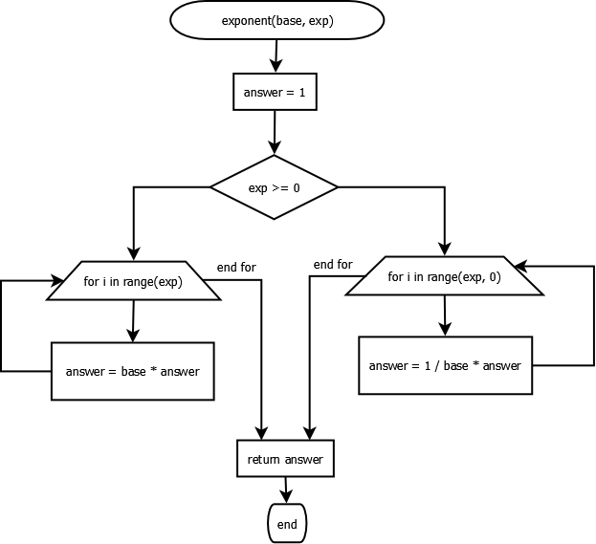

**PROGRAM**

def exponent(base, expo):

answer = 1.0

if exp >= 0:

for i in range(exp):

answer = base * answer

else:

for i in range(expo, 0):

answer = 1/base * answer

return answer

**TESTING**

print (exponent(4, 3))

**OUTPUT**

64.0

**RESULT**

Thus the python program to compute the number to the power of exp (***exponentiation***) has been written, executed and verified successfully.

|  |  |
| --- | --- |
| **Ex No: 4** | FIND THE MAXIMUM OF A LIST OF NUMBERS |

**AIM**

Implement a python program that finds the maximum in a list of numbers.

**ALGORITHM**

Function: **get_max**

**Parameters**: L

Step 1: maxVal = None

Step 2: for number in L

Step 2.1 : If maxval is not set, update with number

Step 2.1 : If maxVal is not set or maxVal is less than number,

maxVal = number

Step 3: return maxVal

**FLOWCHART**

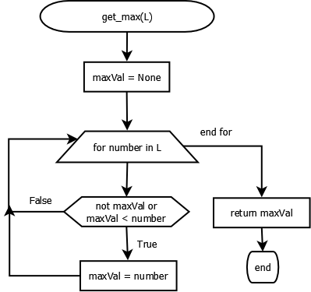

**PROGRAM**

def get_max(L):

maxval = None

for num in numbers:

if not maxval or maxval < num:

maxval = num

return maxval

**TESTING**

L = [1, 4, 6, 7]

print (get_max(L))

**OUTPUT**

7

**RESULT**

Thus the python program to find the maximum number from the given list has been written, executed and verified successfully.

|  |  |
| --- | --- |
| **Ex No: 5** | LINEAR SEARCH AND BINARY SEARCH |

**AIM**

To write a python program for performing linear search and binary search for the given set of inputs

LINEAR SEARCH

**ALGORITHM**Function: linear_search  
parameters: L, key  
 **Step 1:** for number in L:  
 **Step 1.1:** if number == key:  
 return True

**Step 2:** return False

**FLOWCHART**

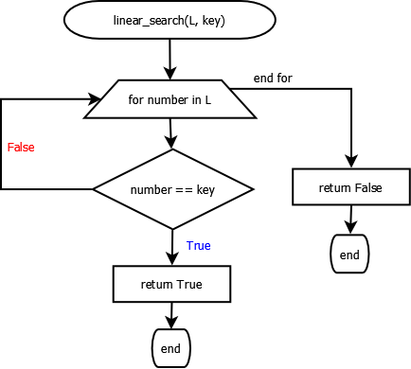

**PROGRAM**

def linear_search(L, key):

for number in L:

if number == key:

return True

return False

**TESTING**

L = [1, 4, 6, 7]

print (linear_search(L, 20))

print (linear_search(L, 6))

**OUTPUT**

False  
True

BINARY SEARCH

**ALGORITHM**

**Step1:** Choose the middle element in the list

**Step2:**  If it matches the middle element, its position in the list is returned.

**Step 3:** If the target value is less than or greater than the middle element, the search

continues in the lower or upper half of the array, respectively, eliminating the

other half from consideration

**FLOWCHART**

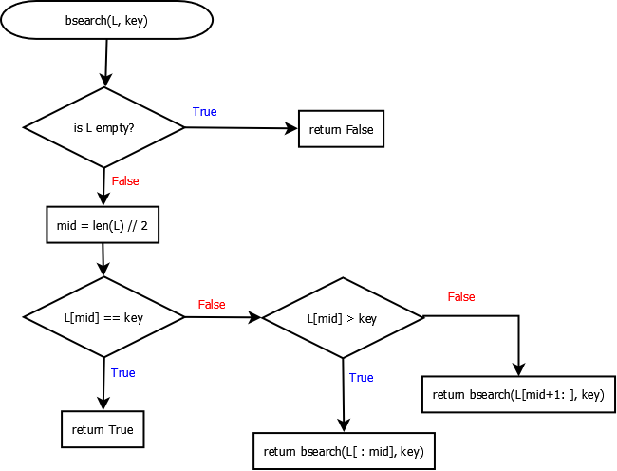

**PROGRAM**

def bsearch(L, key):

if not L:

return False

mid = len(L) // 2

if L[mid] == key:

return True

elif L[mid] > key:

return bsearch(L[:mid], key)

else:

return bsearch(L[mid+1:], key)

**TESTING**

L = [1, 4, 6, 7]

print (bsearch(L, 20))

print (bsearch(L, 6))

**OUTPUT**

False  
True

**RESULT**

Thus the python program for performing the linear and binary search was executed and verified successfully.

|  |  |
| --- | --- |
| **Ex No: 6** | SELECTION SORT AND INSERTION SORT |

**AIM**

To write a python program for sorting the given set of inputs using selection sort and insertion sort

SELECTION SORT

**ALGORITHM**

**Step 1:** Get started from the first element (i = 0): **Step1.1:** Get the unsorted sub list (U)

**Step1.2:**  Find the smallest in the sublist (m)

**Step 1.3:** Find the index of the smallest (j)

**Step 1.4:** Swap the smallest with the element at index (i)

**Step 2:** Increment the index (i) and repeat step 1 until list is sorted

**FLOWCHART**

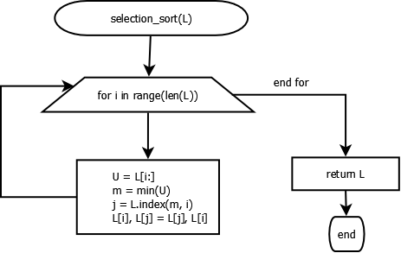

**PROGRAM**

def selectsort(L):

for i in range(len(L)):

U = L[i:]

m = min(U)

j = L.index(m, i)

L[i], L[j] = L[j], L[i]

return L

**TESTING**

L = [12, 4, 7, 56, 2]

selectsort(L)

print(L)

**OUTPUT**

[2, 4, 7, 12, 56]

INSERTION SORT

**ALGORITHM**

**Step1:** Get the List(L) to be sorted

**Step2:** Iterate index from 1 to len(L)

**Step2.1:**  j = index -1  
 key = L[index]   
**Step 2.2:** Until j > 0 and L[j] > key:  
 Step 2.2.1: L[j+1] = L[j]  
 Step 2.2.2: Decrement j by 1

**Step 2.3:** Insert the key at L[j+1]

**Step 3:** Return the sorted list (L)

**FLOWCHART**

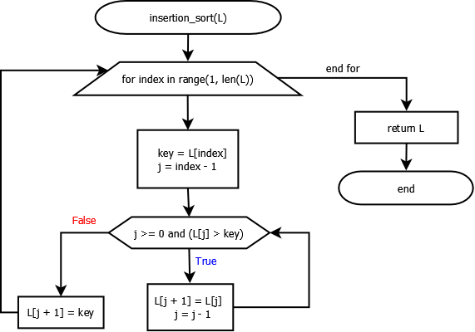

**PROGRAM**

def insertsort(L):

for index in range(1, len(L)):

key = L[index]

j = index - 1

while j >= 0 and (L[j] > key):

L[j + 1] = L[j]

j = j - 1

L[j + 1] = key

return L

**# Test**

print(insertsort([5, 4, 0, 29, 2]))

**OUTPUT**

[ 0, 2, 4, 5, 29 ]

**RESULT**

Thus the python program for performing the selection and insertion sort was executed and verified successfully.

|  |  |
| --- | --- |
| **Ex No: 7** | MERGE SORT |

**AIM**

To write a python program to sort the given list using merge sort algorithm.

**ALGORITHM**

**Step1:** If the list (L) is empty or the list with single element,   
 **return L**

**Step2:**  Recursively split the list into left and right halves, till it contains single element

**Step 3:** Merge( ) the ‘left’ and ‘right’ portions in the sorted order to the way up.

**merge( left, right):**

**Step 1:** Get thesorted lists`left` and `right` to be merged.  
**Step 2:** Initialize the empty `merged` list  
**Step 3:** Loop till `Left` or `right` becomes empty:  
 Step 3.1: Remove the minimum of the left[0] and right[0]  
 and add it to the merged list  
**Step 4:** Add the remaining elements of left/ right to the `merged` list  
**Step 5:** Return the `merged` list

**FLOWCHART**

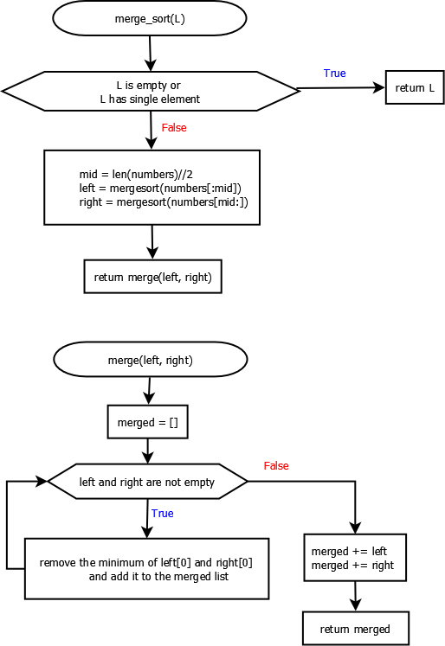



**PROGRAM**

def mergesort(numbers):

if not numbers or len(numbers) == 1:

return numbers

else:

mid = len(numbers)//2

left = mergesort(numbers[:mid])

right = mergesort(numbers[mid:])

return merge(left, right)

def merge(left, right):

merged = []

while left and right:

if left[0] < right[0]:

merged += [left.pop(0)]

else:

merged += [right.pop(0)]

merged += left

merged += right

return merged

**TESTING**

L = [12, 4, 7, 56, 2]

selectsort(L)

print(L)

**OUTPUT**

[2, 4, 7, 12, 56]

**RESULT**

Thus the python program for performing the merge sort was executed and verified successfully.

|  |  |
| --- | --- |
| **Ex No: 8** | FIRST N PRIME NUMBERS |

**AIM**

To write a python program to find the first n prime numbers

**ALGORITHM**

**generate_primes(min, max)**

**Step 1:** Create the empty list ‘primes’  
**Step 2:** For number in range(min, max)

**Step 2.1:** Check whether number is prime using isPrime().   
 If number is prime, append number to primes list

**Step 3**: return primes

**isPrime(number)**

**Step 1:** if number < 2, return False  
**Step 2:** for d in range(2, number):  
 **Step 2.1:** if number is divisible by d,  
 return False  
**Step 3:** return True

**FLOWCHART**

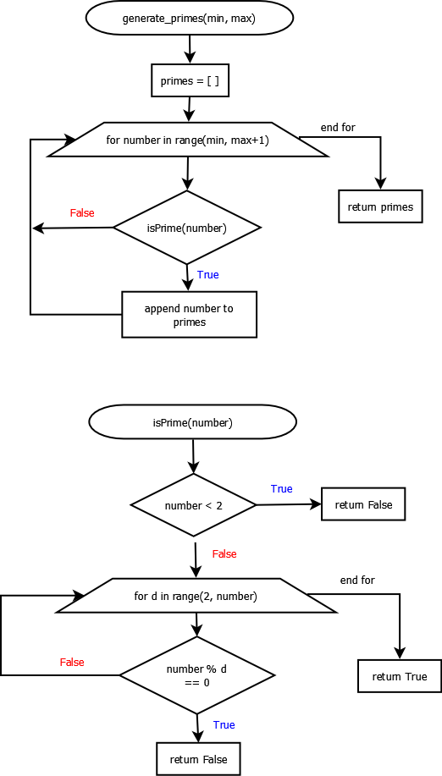



**PROGRAM**

def generate_primes(min, max):

primes = [ ]

for num in range(min, max + 1):

if isPrime(num):

primes.append(num)

return primes

def isPrime(num):

if num < 2:

return False

for i in range(2, num):

if num % i == 0:

return False

return True

**OUTPUT**

Enter number:15

Output:

2

3

5

7

11

13

**RESULT**

Thus the python program for finding the first n prime numbers was executed and verified successfully.

|  |  |
| --- | --- |
| **Ex No: 9** | **MULTIPLY MATRICES** |

**AIM**

To write a python program to multiply matrices

**ALGORITHM**

X is M x N matrix

Y is N x P matrix

The resultant matrix of size M x P, multiplying X and Y,



where   
 i varies from 1 to M  
 j varies from 1 to P

**FLOWCHART**

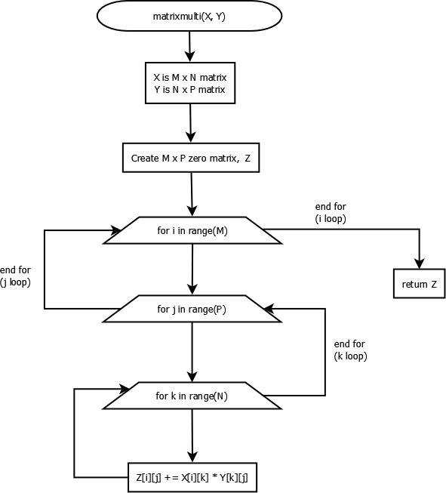

**PROGRAM**

def matrixmulti(X, Y):

# X is M x N matrix

# Y is N x P matrix

M = len(X)

N = len(X[0])

P = len(Y[0])

# Create M x P zero matrix (Z)

Z = [[0] * P for row in range(M)]

if N != len(Y):

print ("Incorrect dimensions.")

return

for i in range(M):

for j in range(P):

for k in range(N):

Z[i][j] += X[i][k] * Y[k][j]

return Z

**TESTING**

X = [[1,2],[3,4]]  
Y = [[1,2],[1,2]]  
print(matrixmulti(X, Y))

**OUTPUT**

[[3, 6], [7, 14]]

**RESULT**

Thus the python program for multiplying two matrices was executed and verified successfully.

|  |  |
| --- | --- |
| **Ex No: 10** | **COMMAND LINE ARGUMENTS  (WORD COUNT)** |

**AIM**

Write a Python program that does counting of words in a file. The program should accept multiple file names when it is invoked and duely process them.

**ALGORITHM**

**Step 1:** Get the filename as command line argument   
**Step 2:** Open and read the file content (text)  
**Step 3:** Split the text with space delimiter ‘ ‘  
**Step 4:** Count and print the number of words after the split

**FLOWCHART**

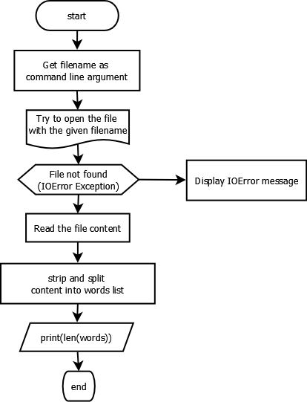

**PROGRAM***wordsCount.py*

import sys

filename = sys.argv[1]

try:

f = open(filename, 'r')

text = f.read()

words = text.strip().split()

print(len(words))

f.close()

except IOError:

print("File not available!")

**TESTING**

*wordsCount.py*

**Python is the multi paradigm programming language**

*In command prompt:*

python3 wordsCount.py sample.txt

**OUTPUT**

**7**

**RESULT**

Thus the python program for counting of words in a file using command line arguments was executed and verified successfully.

|  |  |
| --- | --- |
| **Ex No: 11** | **The most frequent words in a text file** |

**AIM**

Find the most frequent words in a text read from a file.

**ALGORITHM**

**Step 1:** Get the filename as command line argument   
**Step 2:** Open and read the file content (text)  
**Step 3:** Split the text into words with space delimiter ‘ ‘  
**Step 4:** Create the dictionary with the count for each word in the text.  
**Step 5:** Findthe word with the maximum count and print the word

**FLOWCHART**

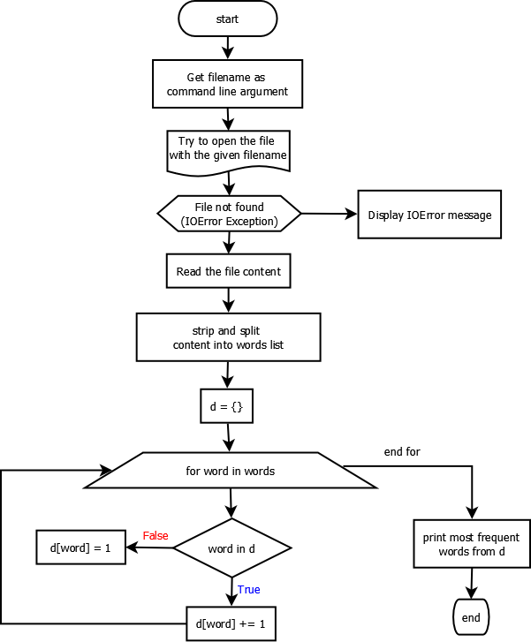

**SOURCE CODE**

import sys

def freq(d):

m = max(d.values())

freq = []

for word in d.keys():

if d[word] == m:

freq += [word]

return freq

filename = sys.argv[1]

try:

f = open(filename, 'r')

text = f.read()  
 words = text.strip().split()

d = {}

for word in words:

if word in d:

d[word] += 1

else:

d[word] = 1

print(freq(d))

f.close()

except IOError:

print("freqWords: File not available!")

**TESTING**

*sample.txt*

**sea shells is in the sea shore**

*In command prompt*

python3 wc.py sample.txt

**OUTPUT**

**[sea]**

**RESULT**

Thus the python program for finding the most frequent words in a text read from a file was executed and verified successfully.

|  |  |
| --- | --- |
| **Ex No: 12** | **Simulate bouncing ball using Pygame** |

**AIM**

To simulate the bouncing ball using pygame.

**ALGORITHM**

**Step 1:**  Import and initialize pygame with **pygame.init()  
Step 2:** Create a graphical screen (Surface) with pygame.display.set_mode().  
**Step 3:** Load ball image and define the rectangle around the image.  
**Step 4:** Inside the infinite loop, move the ball by (2,2) pixels (speed) in x,y coordinates  
**Step 5:** If the ball goes out of the screen boundary, reverse the direction of speed  
**Step 6:** Fill the screen with black, before displaying the next position of the ball to avoid the trail of the ball visible in the animation.  
**Step 7:** Draw the ball in its next position on the screen using Surface.blit() method.   
**Step 8:** The pygame.display.flip() method makes everything we have drawn on the screen Surface become visible.  
**Step 9:** If user triggers quit() event (close button), the simulation stops.

**PROGRAM**

import sys, pygame

pygame.init()

size = width, height = 320, 240

speed = [2, 2]

black = 0, 0, 0

screen = pygame.display.set_mode(size)

clock = pygame.time.Clock()

ball = pygame.image.load("ball.gif")

ballrect = ball.get_rect()

while 1:

clock.tick(30)

for event in pygame.event.get():

if event.type == pygame.QUIT: sys.exit()

ballrect = ballrect.move(speed)

if ballrect.left < 0 or ballrect.right > width:

speed[0] = -speed[0]

if ballrect.top < 0 or ballrect.bottom > height:

speed[1] = -speed[1]

screen.fill(black)

screen.blit(ball, ballrect)

pygame.display.flip()

**OUTPUT**

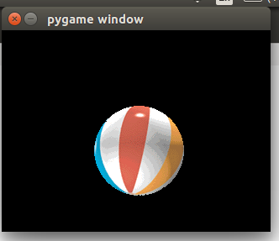

**RESULT**

Thus the bouncing ball using pygame was simulated successfully.

|  |  |
| --- | --- |
| **Ex No: 13** | **Simulate elliptical orbits in Pygame** |

**AIM**

To simulate elliptical orbits in pygame.

**ALGORITHM**

**Step 1:**  Import and initialize pygame with **pygame.init()  
Step 2:** Create a graphical screen (Surface) with pygame.display.set_mode().  
**Step 3:** Draw earth, moon and elliptical orbit  
**Step 4:** Inside the infinite loop, change the center of the moon x1, y1 as follows:

x1 = int(math.cos( degree * 2 * math.pi / 360) * xRadius) + 300  
 y1 = int(math.sin(degree * 2 * math.pi / 360) * yRadius) + 150

**Step 5:** Redraw earth, moon and elliptical orbit  
**Step 6:** The pygame.display.flip() method makes everything we have drawn on the screen Surface become visible.  
**Step 7:** If user triggers quit() event (close button), the simulation stops.

**PROGRAM**

import pygame

import math

import sys

pygame.init()

screen = pygame.display.set_mode( (600, 300))

clock = pygame.time.Clock()

while(True) :

for event in pygame.event.get() :

if event.type == pygame.QUIT:

sys.exit()

xRadius = 250

yRadius = 100

for degree in range(0,360,10) :

x1 = int(math.cos( degree * 2 * math.pi / 360) * xRadius) + 300

y1 = int(math.sin(degree * 2 * math.pi / 360) * yRadius) + 150

screen.fill(( 0, 0, 0))

pygame.draw.circle(screen, (255, 0, 0), [300, 150], 35)

pygame.draw.ellipse(screen, (255, 255, 255), [50, 50, 500, 200], 1)

pygame.draw.circle(screen, (0, 0, 255), [x1, y1], 15)

pygame.display.flip()

clock.tick(5)

**OUTPUT**

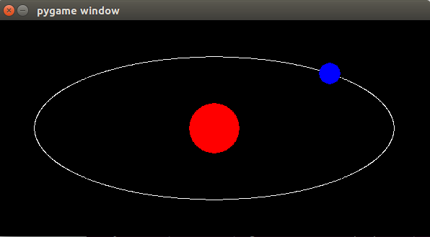

**RESULT**

Thus the elliptical orbits in pygame was simulated successfully.